Assignment 19.
- What is control break statement & what are the statements we can use inside loop explain them.
- control break statements (also known as control break events) are special statements used within a LOOP AT...ENDLOOP or SELECT...ENDSELECT block to process specific lines or groups of lines, typically for calculating totals and subtotals
- They help in grouping data and calculating totals.
- 1.AT FIRST
- 2.AT LAST
- 3.AT NEW
- 4.AT END OF
- 5.ON CHANGE OF………ENDON.
- 1.AT FIRST……..ENDAT.
- Used within the LOOP statement and Executes at very first record.
- 2.AT LAST………ENDAT.
- Executes last record in table.
- It is commonly used for displaying grand totals.
- 3.AT NEW……..ENDAT.
- Triggers when the value of the specified field changes.
- Used to start a new group and print group headings(First record of that Group).
- 4.AT END OF……..ENDAT.
- Triggers when the value of the specified field changes(last record of that group).
- Used to start a new group and print group headings.
- 5.ON CHANGE OF…….ENDON.
- It is similar to AT NEW.
- Executes when the value of the specified field changes during loop processing.
- Progam:
- 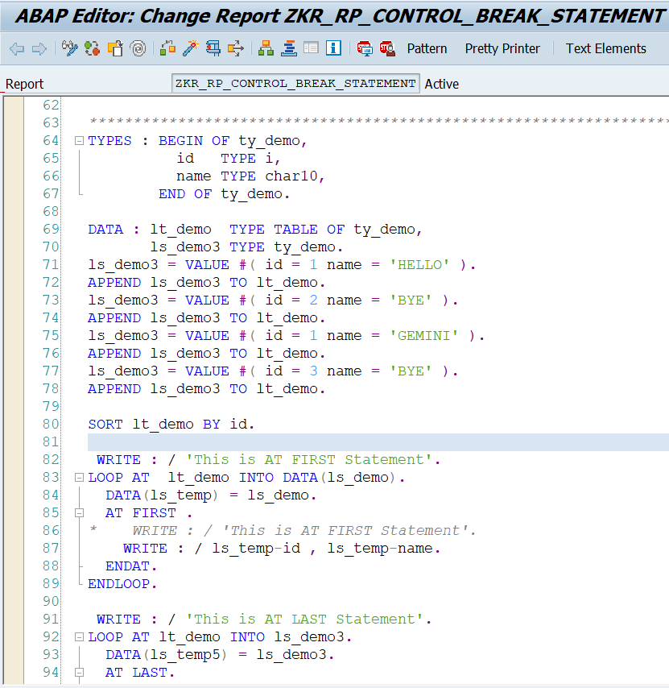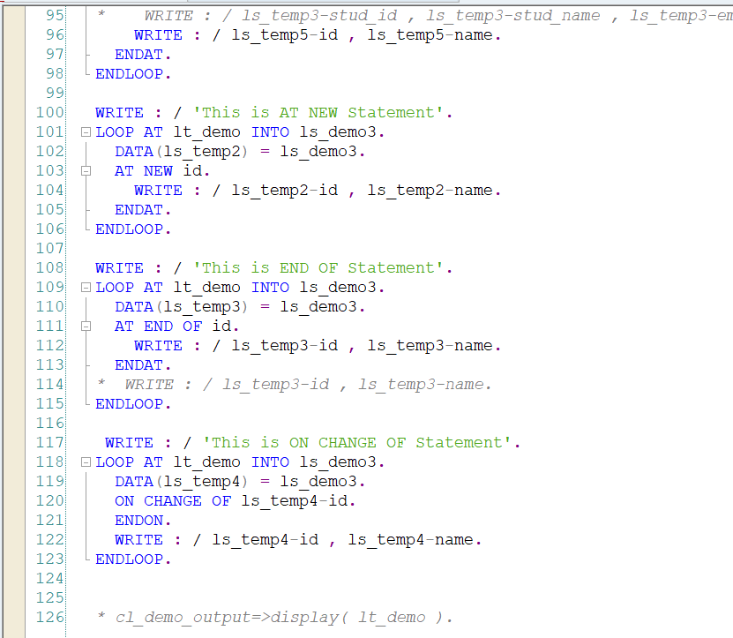
- Output:
- 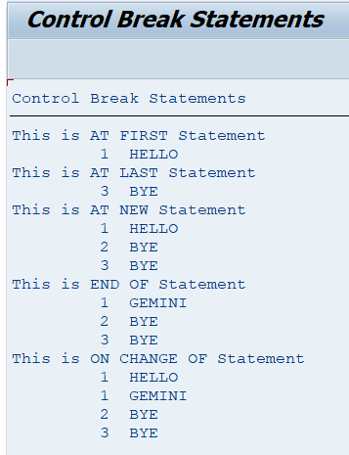
- Different between At New & On change.
Features | AT NEW | ON CHANGE
Definition | Triggers when a new value of a field starts | Triggers when field value changes
Usage | Can only be used inside a LOOP AT...ENDLOOP on an internal table work area. | Can be used in any loop construct (e.g., LOOP, SELECT, DO, WHILE).
Type | Control break statement | Old/obsolete statement
Usage | Used in modern ABAP | Not recommended
Requirement | Requires sorted table | Does not strictly require sorting
Reliability | More accurate for grouping | Less reliable.  (Replaced by AT NEW)

- In "SPFLI" DBT take Condi, Period, City from, CharID , Cityto, Distance, Fltime & print it's short description and also print particular carid distance & fltime as explained in today's session.
- 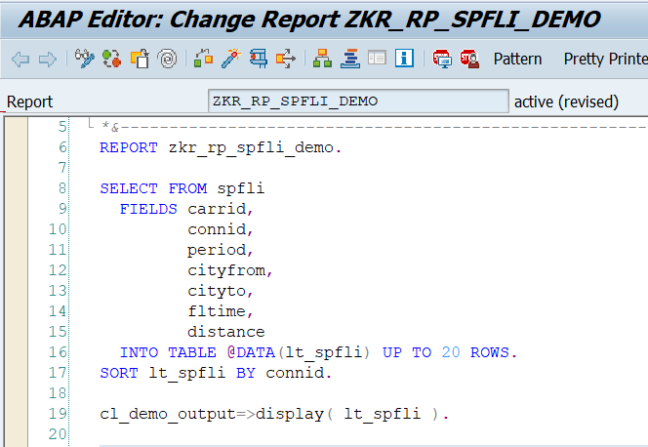
- output
- 